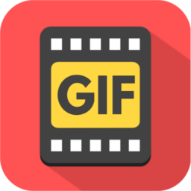

GifFactoryApp 1.0.0
Created and documented by Storix
Email: stuffokator@gmail.com

Gif Factory App User Manual

Thank you for purchasing my App. If you have any questions that are beyond the scope of this help file, please feel free to email via my user page contact form here:
http://codecanyon.net/user/storix.

Thanks so much!

Overview
Gif Factory App is an iOS application that makes it possible to create animated gifs with just a few taps. If you have some photos and/or videos that you want to turn into the GIF sequence, then try this app. It was specifically designed to make this process quick and easy.
As you may know, the standard iOS Photos App (the application that is used to hold all your media collections) doesn’t allow you to preview GIF files: it just displays them as still images. So, even if you don’t want to create the GIFs from scratch, GIF Factory App still can be helpful: you can use it to play all your saved animations and edit them as you wish too.
How to Convert Images into GIF

- Tap the “Add” button that is shown in Fig. 1 as a `plus` sign. Then select from the appeared action sheet `Create GIF from Images` menu option.

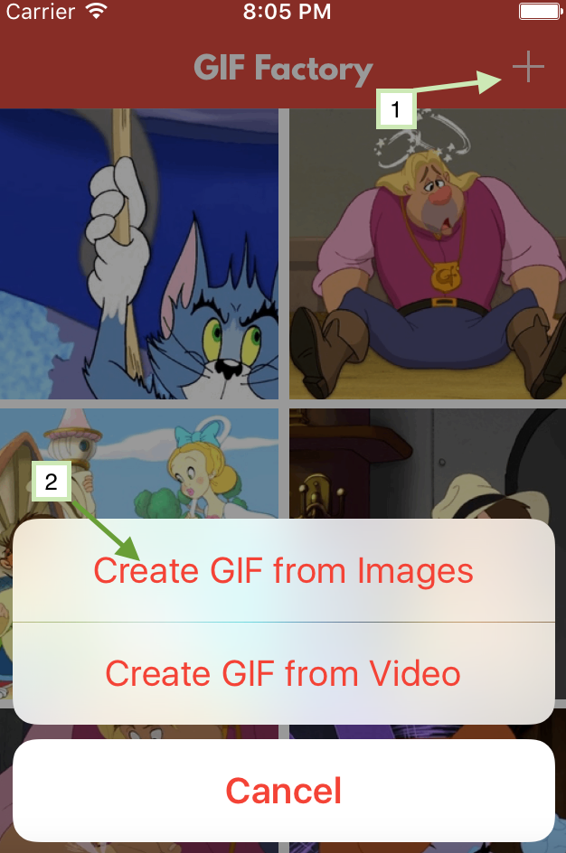

Fig. 1 – The app screenshot showing which menu options should be selected to start creating GIF from the images.

- On the next screen you can choose images from all of your saved collections. As depicted in Fig. 2, when you tap on the images the label in the bottom right corner displays the future GIF sequence number. When you are satisfied with the selected photos tap `Done` button to start a new edit session.

Note: If you have some saved GIFs you can preview them using long tap.

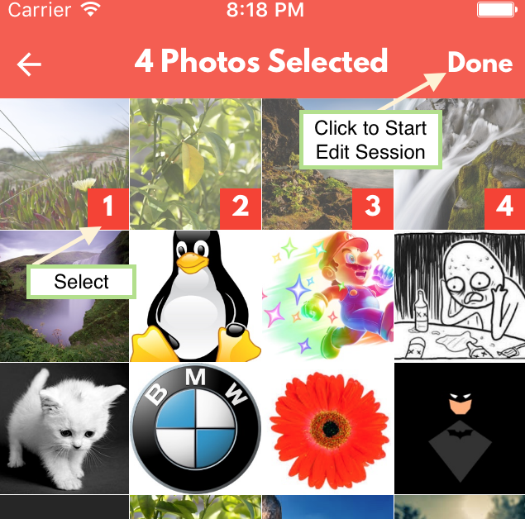
Fig. 2 – The app screenshot showing how to select images to create GIF.

- Now you should see the main editor scene, where you can preview all the selected photos, rearrange them as you wish and change the output GIF settings.

To change the output animation frames order you can use the functionality provided by the long press gesture recognizer. On long tap the selected frame is resized and its sequence number changes to the “?” symbol to provide the visual feedback. Feel free to drag it in any direction you want. Release the finger to set the frame into the new position.

To change the GIF settings tap the `Settings` button. The settings view is depicted in Fig 3.

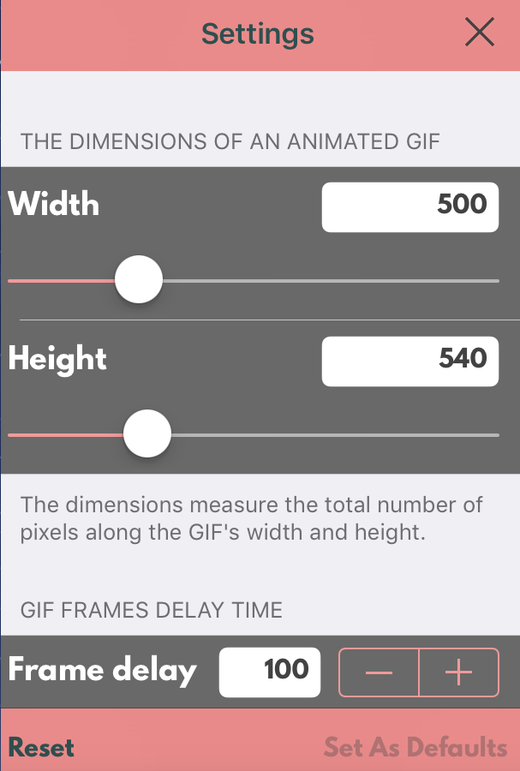

Fig. 3 – The app screenshot showing the view where the user can change the output GIF file settings.

Here is the list of the GIF parameters you can configure:
- The dimensions: the total number of pixels along the GIF's width and height;
- Frame delay: the amount of time in seconds to wait before displaying the next frame.
- Loop count: the number of times to repeat an animated sequence.
Note: 0 means loop forever.
- Content mode: options for fitting an image’s aspect ratio to a requested size.
  - `AspectFit` mode scales the image so that its larger dimension fits the target size. Use this option when you want to preserve the original images aspect ratio.

Note: For proper combining the images with different aspect ratio the white background color is used.

  - `AspectFill` mode scales the image so that it completely fills the target size. In this mode all the GIF frames will be fully visible (without background color).

- Transparency: indicates whether the transparency should be preserved for the images which support the alpha channel (such as .png images);
- Cropping level: this parameter is used to remove areas from the GIF frames in the range from 0.0 to 1.0. The default value of 1.0 means the images will remain unchanged. 0.0 is treated the same way. 0.5 means remove half of the image starting from the bottom right edge.

Note: this can be helpful in reducing the output file size.

Using `Set as Defaults` button you can save all the currently input values so that they will be loaded during the next editing sessions.
Using `Reset` button you can reset all the changed settings to the previously stored or the default state.

- After configuration of the all required settings tap the `Preview` button on the bottom right edge of the Editor scene. You will be presented with the screen where you can preview the resulting GIF and optionally save it.

How to Convert Video into GIF

The basic steps are the same as described above for converting the images. The most important step here is to choose the appropriate time range for extracting frames from the chosen video file.
Fig. 4 depicts this step with the details regarding the available options.
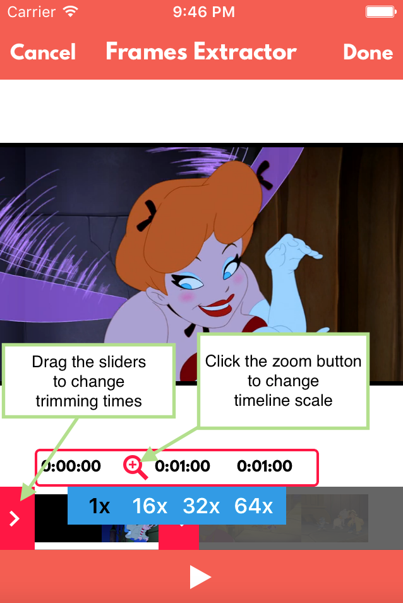

Fig. 4 – The app screenshot showing the view where the user can choose time range to extract frames from the video file.

Note: The maximum allowed time for extraction is 60 sec. And it is NOT recommended to extend it because this can lead to app crashes due to the memory exhaustion.

To simplify the time range selection process it is possible to change the timeline scale. After tapping the zoom button you will be presented with the different zoom options:
- 1x – The timeline fits the current available screen width;
- 16x – Increase the timeline width by 16 times.
- 32x – Increase the timeline width by 32 times.
- 64x – Increase the timeline width by 64 times.
For example, in case of a large video file it can be more appropriate to select 32x zoom option.

How to Preview Saved GIFs

All your saved animations are presented on the main screen collection view. To preview, share or delete the necessary GIF just tap on it. You will be presented with the preview controller where all these options are available.
In addition you can also swipe to the left/right direction to load the previous/next GIF from the collection.

Thank you for your reading. Hope you’ll enjoy this App!

